1.Go to the lambda service and create function

🡪 First we will create a roll for Lambda and give full permission to EC2, see below for role

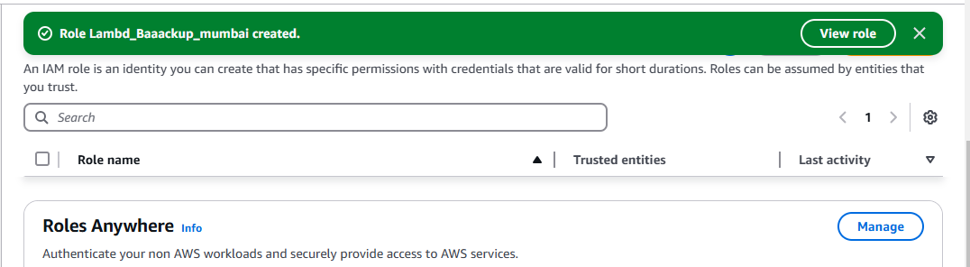

2. Now we will create function and attach existing role that which we have created under

Change default execution role we will use existing role option and attach that role

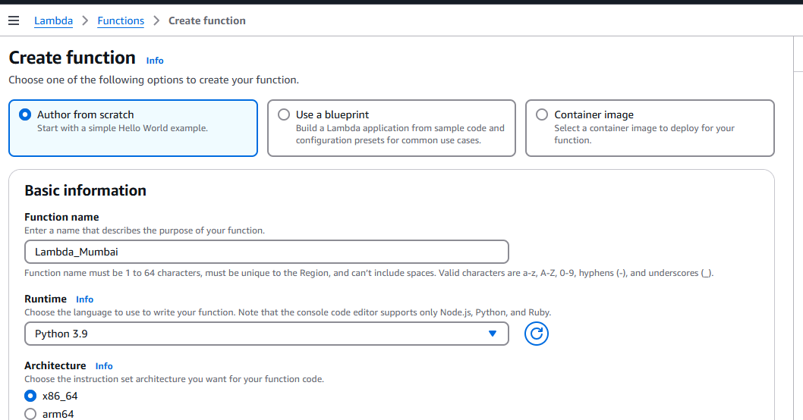

3.**Attach role to the Lambda**

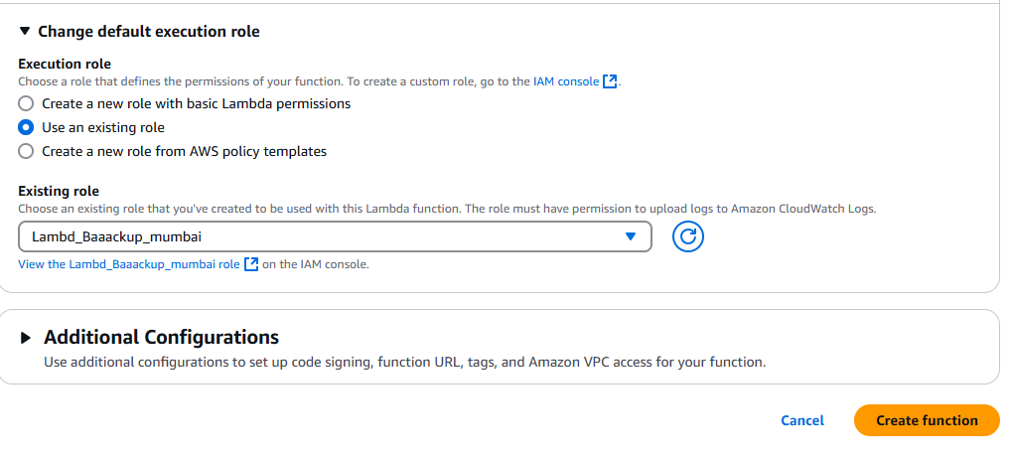

4**.lamda created and now we will put our code in code source as below mentioned**

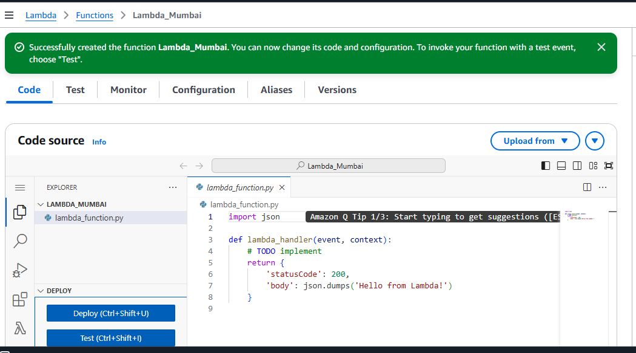

5.**Code has been added at code source**

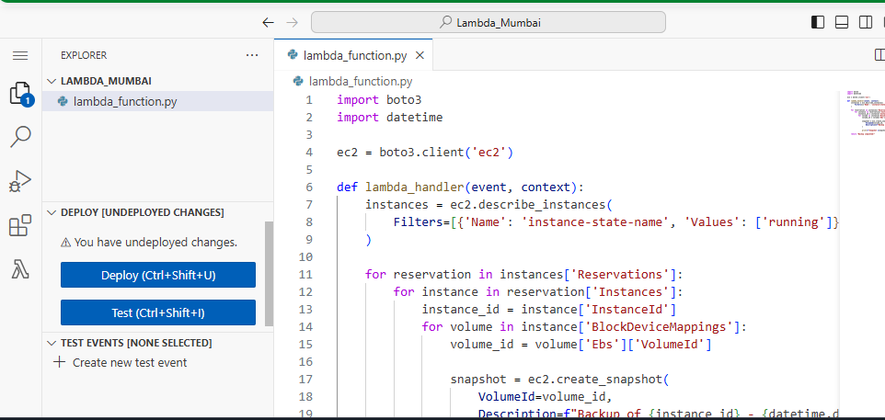

6.**Now we will deploy the code and its show successfully automated as below**

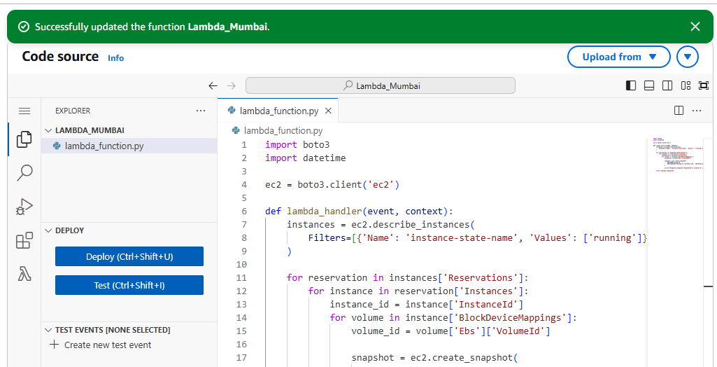

**7.Now we will test our code and we will add new event for test**

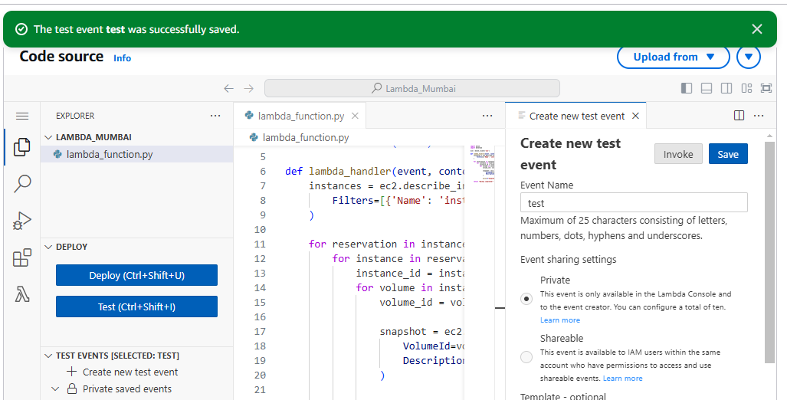

**8.Below snapshot of running instances has been created as below**

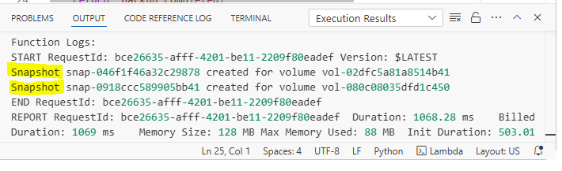

**9. Now post to termination of one instance it will take of only one running instance**

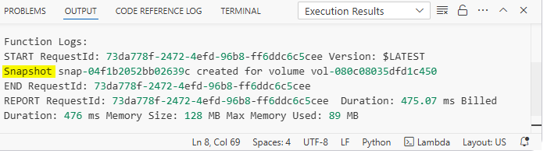

**10.There is no snapshot of stopped instances as below**

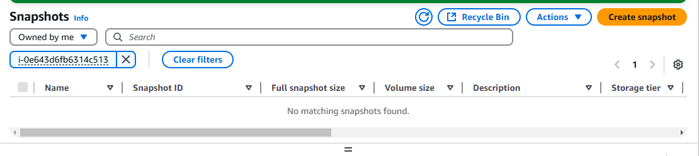

**11. We will add trigger to run lambda at certain time, we will add new rule and description and schedule expression for 1 minute**

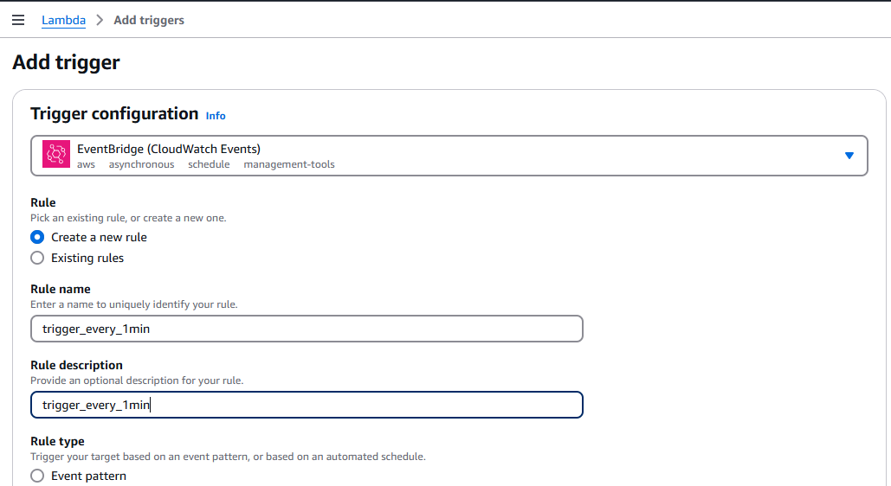

**Added Schedule expression for 1 minute**

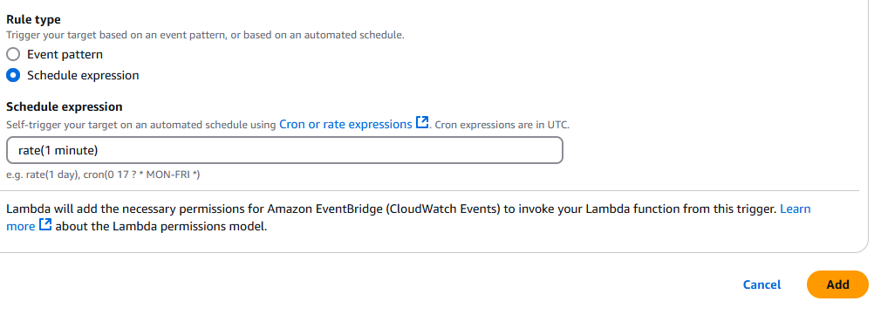

**12.Post to 01 minutes below snapshot created via Lambda**

